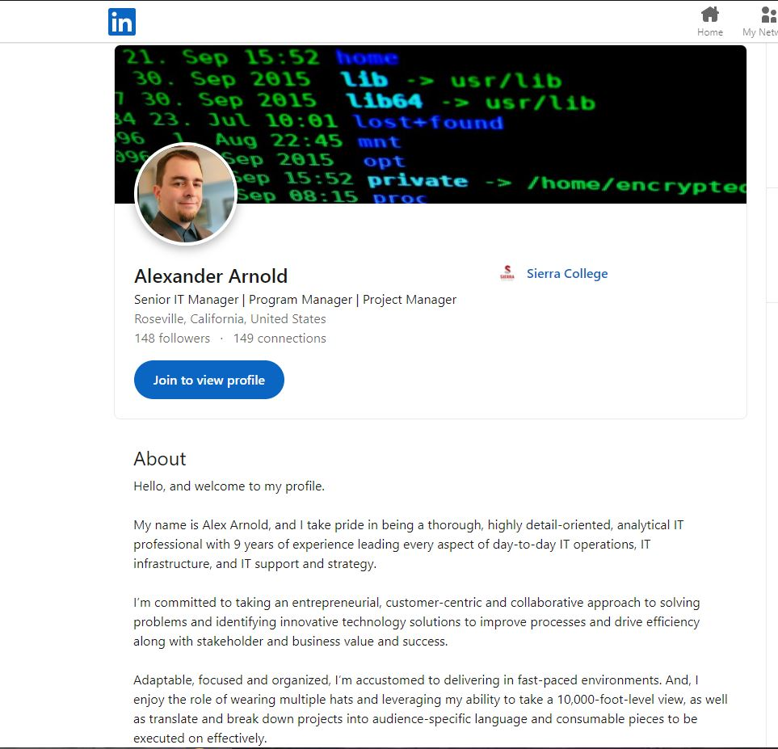

URL: <https://www.linkedin.com/in/alexander-arnold-40b6818a/>

For the suggestions listed in the Using LinkedIn to Find a Job or Internship tip sheet I have already included most of the suggestions that were listed. I used a professional resume crafting service to improve my resume a few moths ago. Thy actually used all of the suggested tips and a few extras. One of those extras was to find 3 sample job descriptions and use them as the basis for getting the key words and phrasing that the recruiters are looking for. The other thing that I was told is that a resume should have a 40% to 60% match with the job description to pass any auto filtering. To little and your resume is dropped and to much your resume will also be dropped. All of the listed suggestions are great ways to improve a resume or increase the chances of getting a response.